**“GREAT TEACHERS** envision the future”

Educational Leader and Mentor on the National Nominating Committee since the 28th of October 2016. https://www.envisionexperience.com

**Awarded**

**Top**

**100**

**Classroom**

**s**

**in the country**

**for the school**

**year 2015/2**

**016**

**for the most minutes read.**

**min.)**

**(39,060**

VIPKID TEACHER since June 2017

.

VIPKID is a leading Chinese online education

firm

that

offers an American elementary education

experience

to Chinese students aged 4

-

12

.

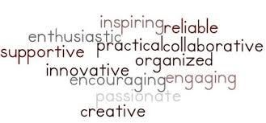

**Sandhills**

**Writer**

**’s**

**Conference**

First Place

winner for

Children

’s

Literature

March

2009

,

21

Book

Title:

“

Excuses

”



Lifetime

Member

since

March

18

2011

,



PLEDGE MEMBER SINCE 2015.

n

ea.

org/bullyfree